H.T No
Regulations:
A17


Sreenidhi Institute of Science and Technology
(An Autonomous Institution)
Code No: 6K301 Date: 23-Dec-2019 (FN)

B.Tech II-Year I-Semester External Examination, Dec-2019/Jan-2020 (Supplementary)
Strength of Materials-I (CIVIL)

Time: 3 Hours Max.Marks:75

Note: a) No additional answer sheets will be provided.
b) All sub-parts of a question must be answered at one place only, otherwise it will not be valued.
c) Missing data can be assumed suitably.

Part - A Max.Marks:25

Answer all QUESTIONS.

1. | The length of an aluminum rod 10mm diameter and 400mm long increases to 400.15mm when subjected to a tensile force of 2kN. Find the stress in bar and young’s modulus. | [3M]
2. | A cantilever is 3 m long carries a concentrated load of 40kN 1.5m from the fixed end and a concentrated load of 30kN at free end. Draw SFD and BMD. | [3M]
3. | Determine radii of gyration for i) triangular section and ii) circular section, considering standard notation. | [3M]
4. | Explain Macaulay’s method to determine slope of a beam. | [3M]
5. | When will be a Mohr’s circle for a given state of stress will be a point of zero radius? | [3M]
6. | Draw shear stress distribution for an I section. | [2M]
7. | Differentiate between point of inflexion and point of contra flexure. | [2M]
8. | Write the assumptions in deriving pure bending equation. | [2M]
9. | State maximum shear stress theory. | [2M]
10. | Calculate section modulus for a circular section with diameter ‘d’. | [2M]
Part – B Max.Marks:50
ANSWER ANY FIVE QUESTIONS. EACH QUESTION CARRIES 10 MARKS.

11. | a) | A bar of uniform thickness and length ‘l’ has its depth increasing from ‘d’ at one end to ‘D’ at the other. Determine the deformation of the member subjected to a tensile force P? | [6M]
 | b) | find the stress induced in a bar made of material density ’ρ’ and length ‘l’ and cross-sectional area ’A’ subjected to its self-weight. | [4M]
12. | a) | Draw SFD and BMD for a simply supported beam as shown in figure below.  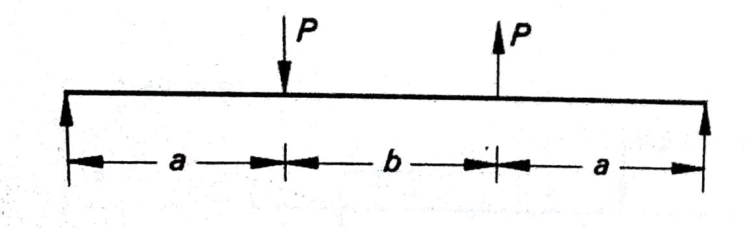 | [5M]
 | b) | A simply supported beam has a span of 5m and carries a UD load of 20kN/m in the left half and 40kN/m in the right half. Find the position and magnitude of maximum bending moment | [5M]
13. | a) | A cantilever beam of span L carries a point load ‘P’ at free end. If the beam is to have a uniform strength, find the variation in breadth keeping the depth constant? | [4M]
 | b) | A short column of rectangular cross-section 200mm along Y-axis by 400mm along X-axis is made of material which has maximum tensile stress as 25MPa and compressive stress as 90MPa. If the column carries a load of 1500kN, what eccentricity is permitted along two principal axes? | [6M]
14. | a) | A simply supported beam of length ‘l’ carries a moment at a distance of ‘a’ from left end. Compute slope at both ends and deflection at the center. EI is constant. | [7M]
 | b) | A simply supported beam carries appoint load 40kN at a distance of 2m from left support whose span is 8m. Compute slope at both ends. E = 200GPa and I=8000cm⁴ | [3M]
15. | a) | A bar of cross-sectional area 1000mm² is subjected to an axial tensile force of 70kN. Find the normal, tangential stress on a plane whose normal of which makes an angle of 30⁰ with axis of the bar. | [5M]
 | b) | Solve the above problem using Mohr’s circle. | [5M]
16. | a) | A beam of square cross section whose diagonal is 200mm is placed in such a way that one of its diagonal is horizontal is subjected to a shear force of 500kN.Draw the shear stress distribution. | [8M]
 | b) | Explain maximum principal stress theory. | [2M]
17. | a) | A steel tube of outside diameter 250mm and thickness 10mm is 2m long, carriesa load of 1000kN. Find the change in length and thickness if E=200GPa and poison’s ratio is 0.3. | [4M]
 | b) | A cantilever is 5 carries an UD load of 30kN/m and a point load 10kN at free end. Draw SFD and BMD. | [3M]
 | c) | A circular log of wood is used as a beam. If the diameter of the log is 200mm, find the moment of resistance of the section. Permissible stresses are 10N/mm² in tension and 18N/mm² in compression. | [3M]
18. | a) | state and explain moment-area theorems. | [4M]
 | b) | Derive an expression for the stresses on an oblique plane of a rectangular body, when the body is subjected to a simple shear stress. | [4M]
 | c) | Explain the limitations of theories of failure. | [2M]

-- 00 -- 00 –

